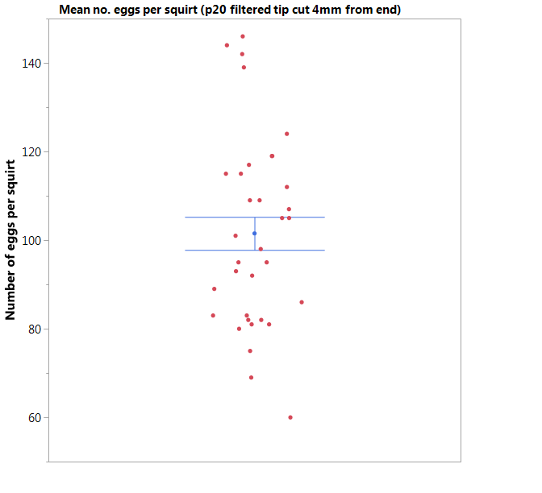
Figure 1: shows the mean±S.E. number of eggs in an egg squirt carried out using a p20 filtered pipette tip cut 4mm from the end of tip. Number of practice squirts performed N=34.

